Andrew Seamon

CPS 3320-01

Final Project Reflection

5/5/2021

New Jersey PPP Loan Distribution Analysis

**Motive**

The motive behind this analysis was to introduce non-business-owners to the world of PPP loans and the difficulty of running a business during a pandemic. Before starting this project, I was not sure what to create. Though speaking with friends and family about what I should produce (crime statistics analysis, PPP loan analysis, AI powered license plate reader), not one person mentioned the PPP analysis unprovoked. This led me to believe that they did not know what it was. Knowing that a good friend of mine owns a family restaurant, I felt the need to spread knowledge of PPP loans and why they are crucial to the success of small businesses.

**Development**

During development of the codebase, I was faced with many different types of issues. For example, learning to use a Jupyter Notebook while actively using it, fixing the formatting errors within the CSV file, and finding meaningful ways to display the data itself. Unfortunately, there were also many external issues during development. Multiple times during the past few weeks, I was solely responsible for my grandmother, and had no time to continue development. This led to an estimated 60% reduction in development time, accounting for other courses as well. In addition to reduced development time, I also struggled through learning MatPlotLib and its specifics. Thanks to some kind Redditors and a few friends, I was able to get the basics down.

**Findings**

Firstly, I would like to outline some statistics and facts:

* According to the New Jersey Department of State, there are 861,000 small businesses, and more are created regularly.
* The deadline to submit a PPP request in New Jersey was on June 30, 2020 (later extended to August 8, 2020).
* Stay-at-home orders in New Jersey started on the night of March 21, 2020 at 9:00 PM

During my analysis of the PPP loan distribution in New Jersey, I learned a ton about business ownership, city bias, and necessity. According to the dataset, there were 973 white-owned businesses, 26 black/African American-owned businesses, and 269 Asian-owned businesses. This means the distribution is around 80% White, 21% Asian, and 2% African American.

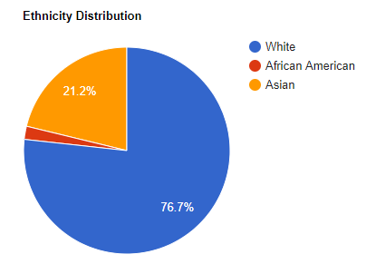

I also wanted to see if PPP loans were “worth it” in the sense that they could’ve saved jobs and livelihoods. So that’s what I did. According to the dataset, the top five industries who received loans were Restaurants (39,043), Plumbing/HVAC (26,063), Physicians (15,579), Law Offices (17,444), and Computer Programming (10,895). This chart is shown below:

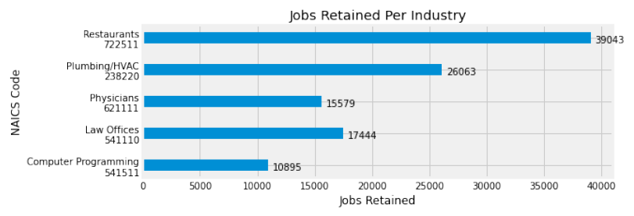

After that, I wanted to see how many businesses claimed a loan in each bracket. As expected, the curve is quite steep as you get to the larger loan amounts. The dataset showed that there were 163 businesses receiving between $5 million and $10 million, 844 businesses receiving between $2 million and $5 million, 1822 businesses receiving between $1 million and $2 million, 6790 businesses receiving between $350K and $1 million, and 12,239 businesses receiving between $150K and $350K. This data is displayed below.

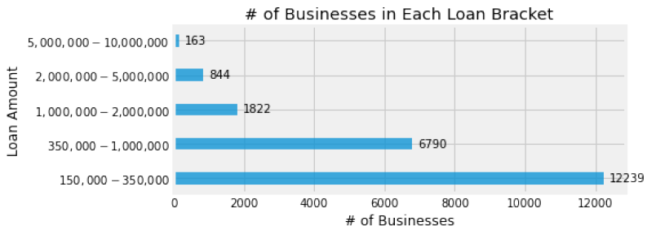

**Reflection**

Overall, I wish I could have done more exploration within this dataset, which unfortunately was cut short by a ton of external factors. Through my analysis I learned that there are many businesses that most likely went bankrupt or closed down before PPP Loans were created. I believe this is a combination of the first stay-at-home order combined with the late creation of PPP loans.